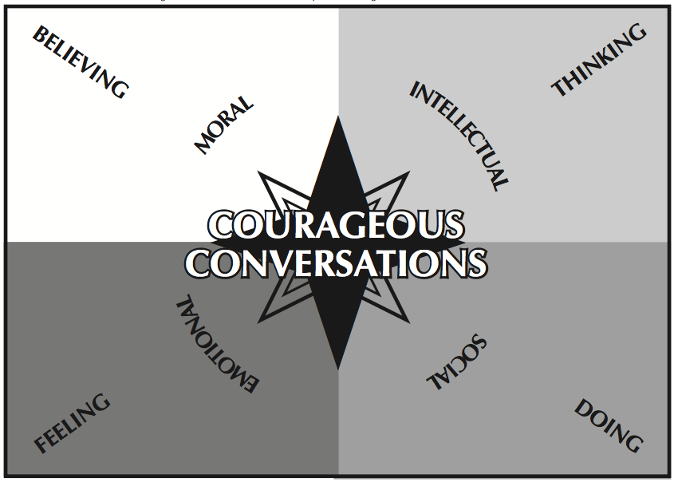

Purpose: “as a personal navigational tool to guide participants through these conversations…helps us to know where we are personally as well as to recognize the direction from which other participants come.” (Singleton 2015)

The 4 Points are:
- EMOTIONAL: responding to information through feelings (when racial issues strike us at a physical level and causes sensations such as anger, sadness, joy, or embarrassment).

- INTELLECTUAL: response to a racial issue or information may be to personally disconnect or to search for more information or data. Our intellectual response is often verbal and based in our thinking.

- MORAL: responding from a deep-seated belief that relates to the racial information or event. Moral views are from the “gut” and may not be verbally articulated.

- SOCIAL: connecting and responding to racial information through actions and behaviors.

